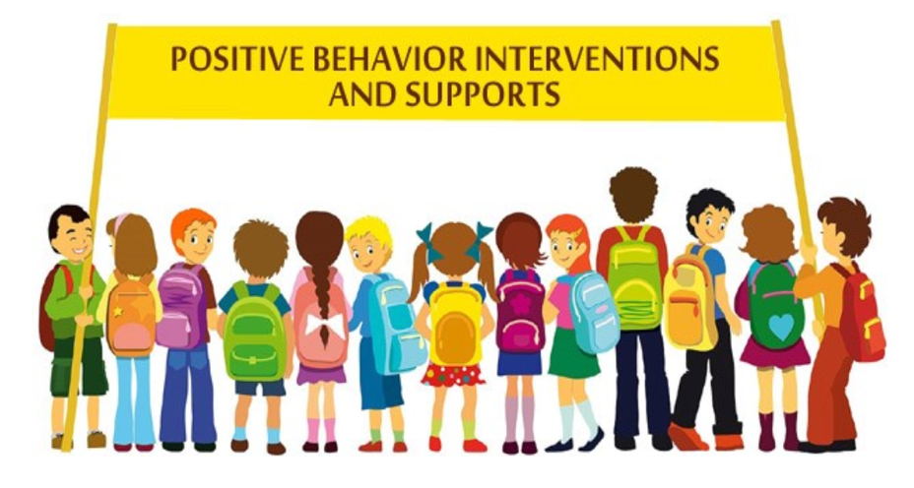A collaboration between Townsend JH, Family Engagement Cent

**This parent workshop will be held at Dickson Elementary-Multi-Purpose Room.**

***3930 Pamela Drive***

***Chino, CA 91710***

**Please register by clicking the link below.**

**January 27**

**6:00 - 7:30 pm**

**You may also register by calling or emailing:**

**Ibis Cordero**

**Coordinator, Parent and Family Engagement**

**ibis_cordero@chino.k12.ca.us**

**909-628-1201 ext. 5601**

**Brenda Froya**

**School Community Liaison Bilingual – Spanish**

**brenda_froya@chino.k12.ca.us**

**909-628-1201 ext. 5602**

CVUSD Family Engagement Center & MTSS-B Counselors present

**CVUSD Mental Health Supports Workshop**

For parents/guardians

of

Don Lugo HS, Ramona,

Briggs, Borba, Dickson, Marshall, Newman

*During this workshop you will learn:*

* The importance of Social and Emotional Intelligence/Learning
* How CVUSD is addressing behavior under the PBIS framework

***Save your spot.*** [***Register here!***](https://forms.gle/pS6B511ZdmP2uGgH9)